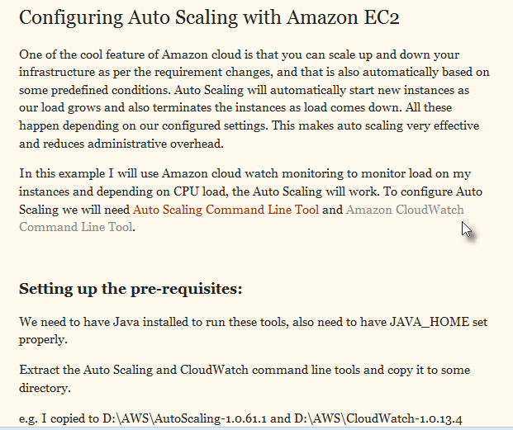
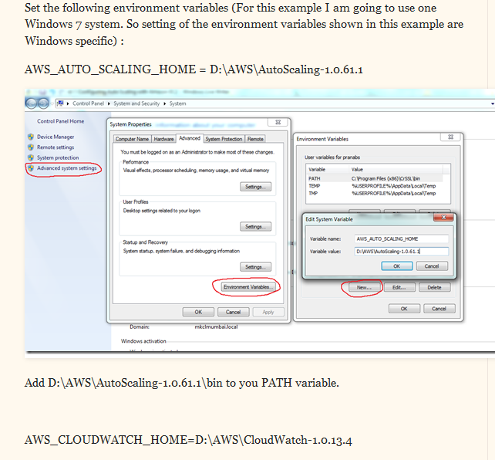
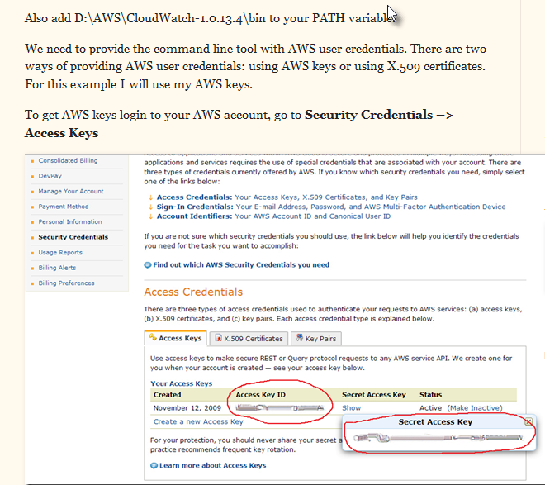
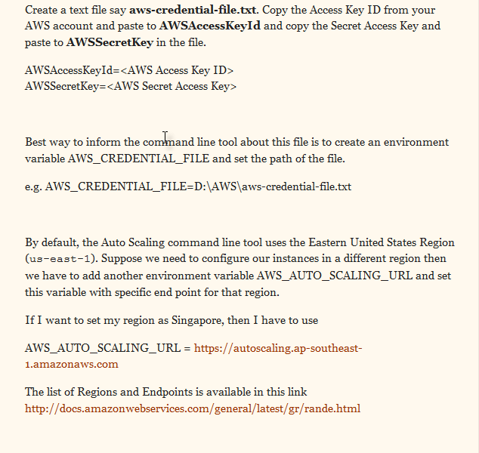
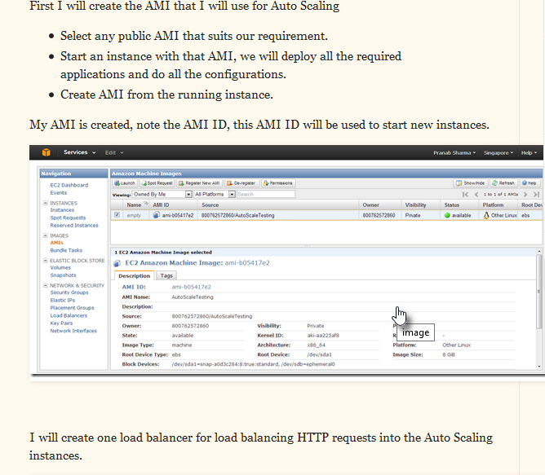
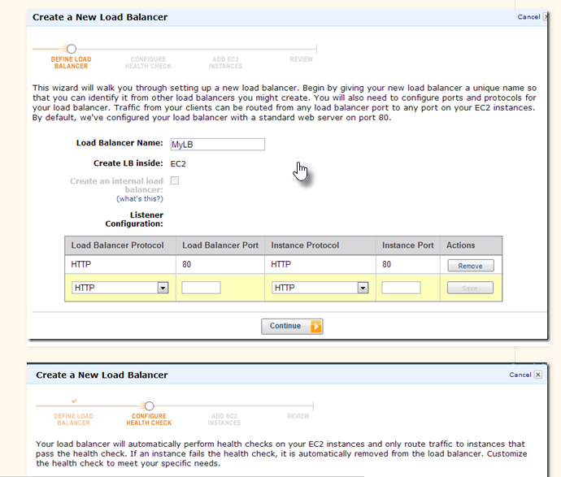
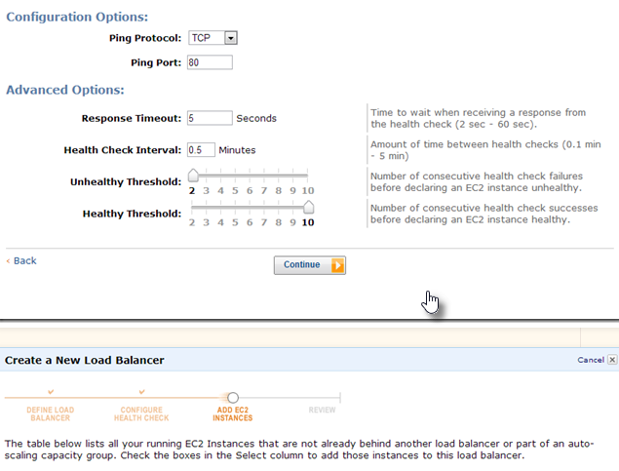
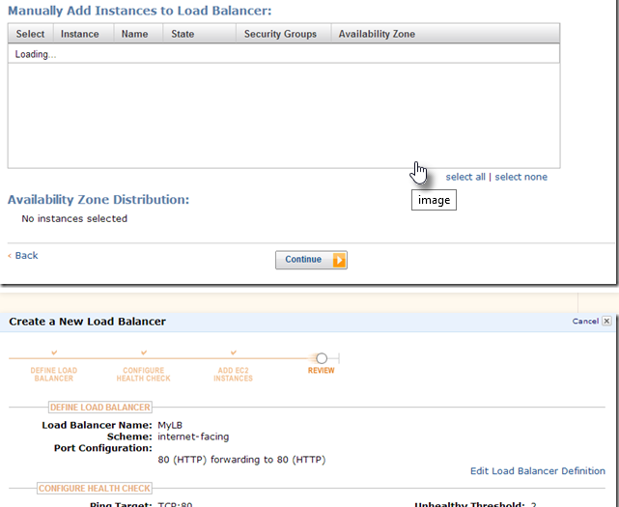
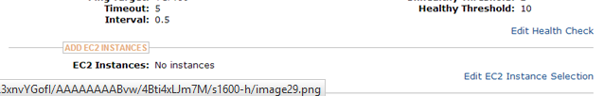
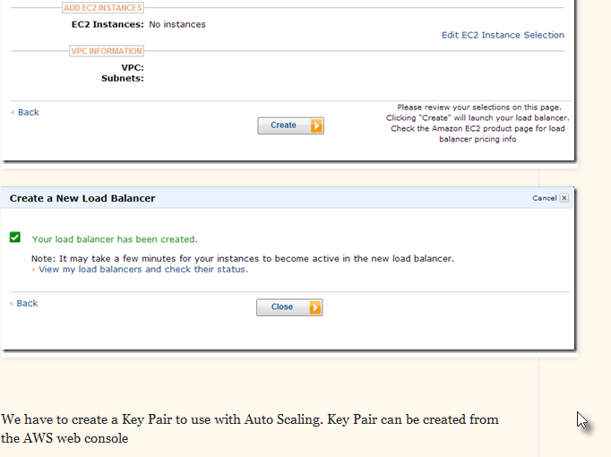
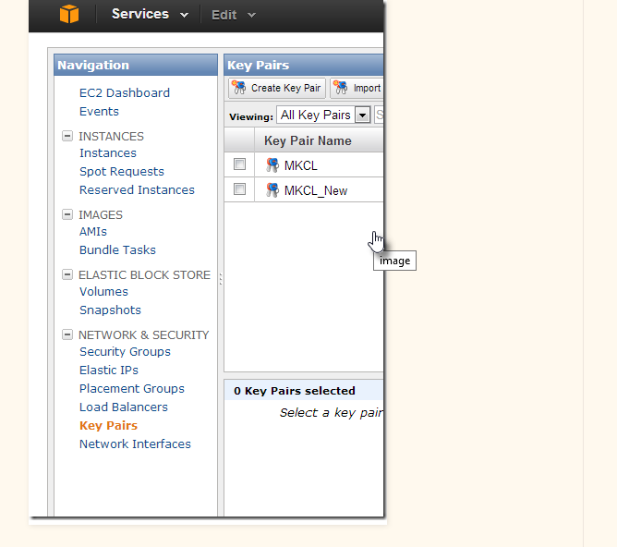
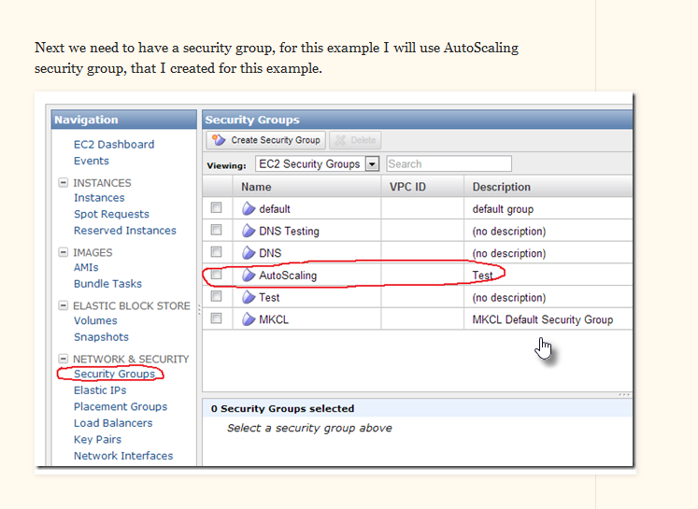
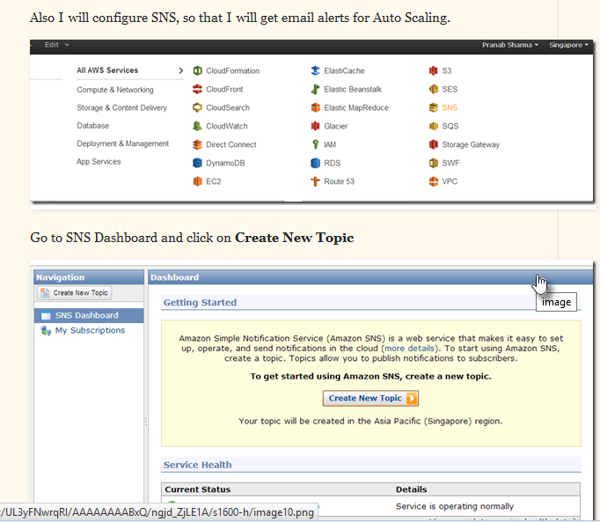
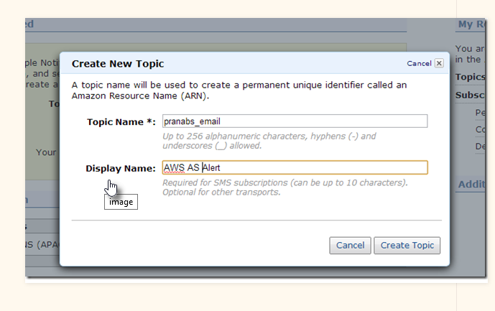
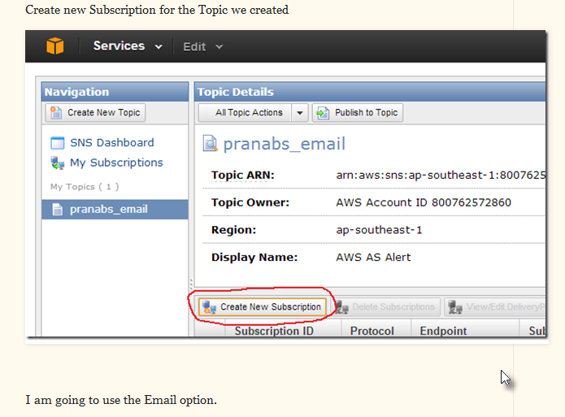
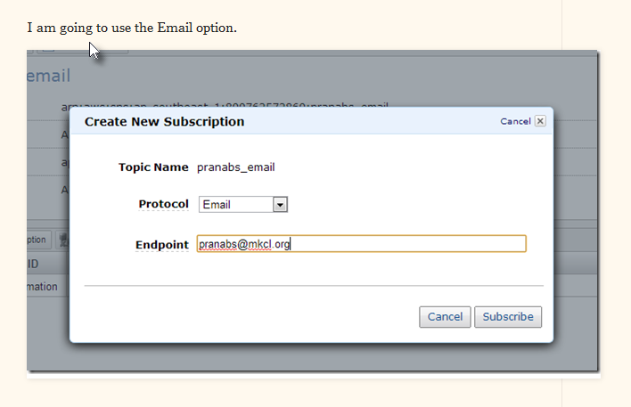
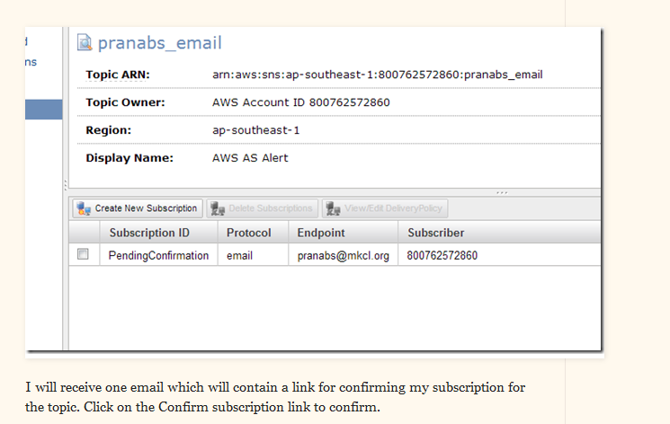
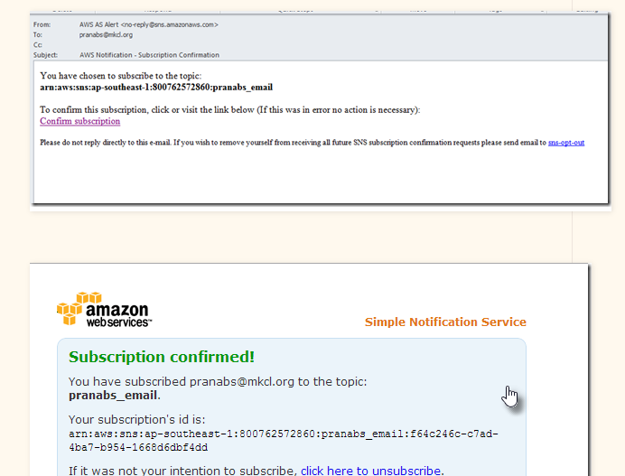
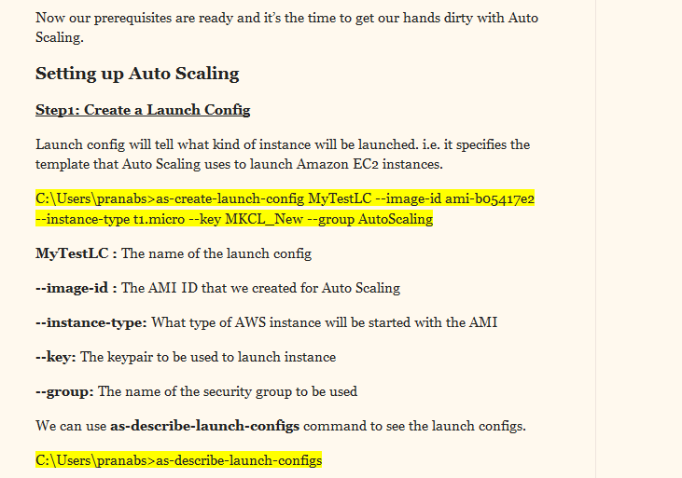
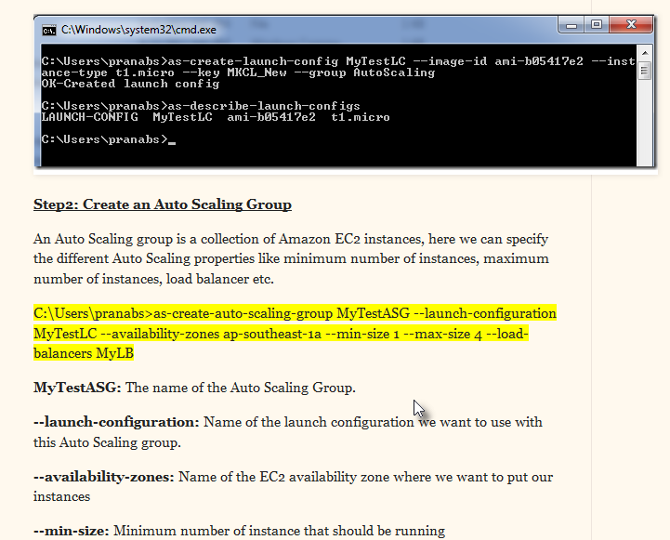
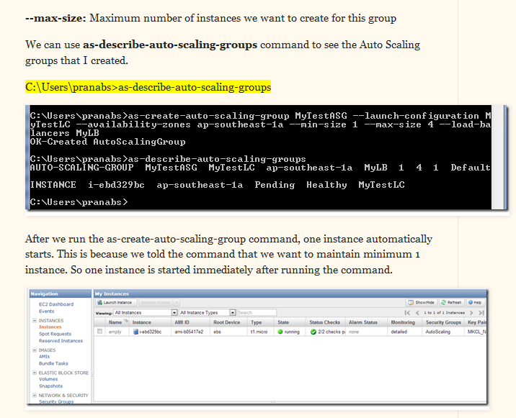
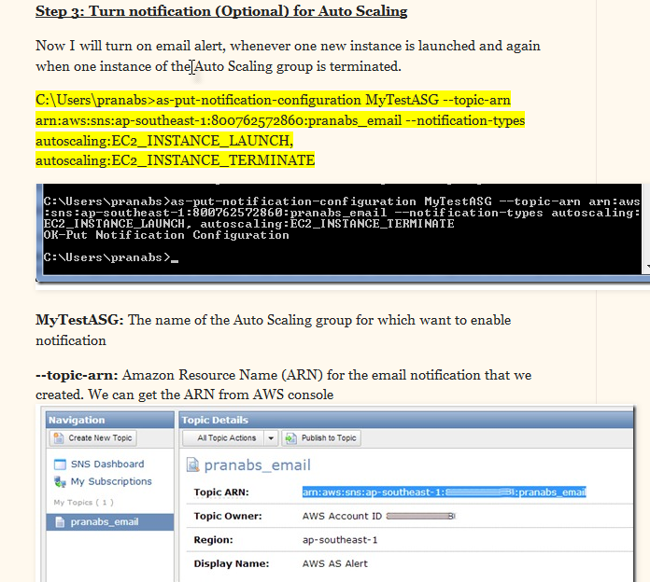
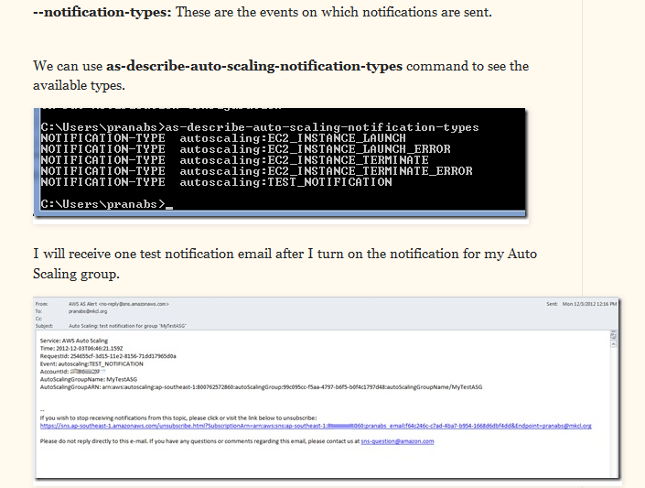
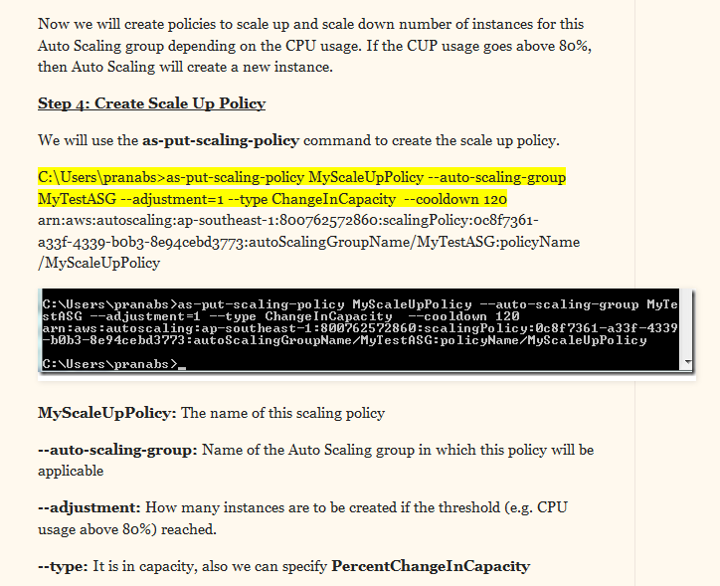
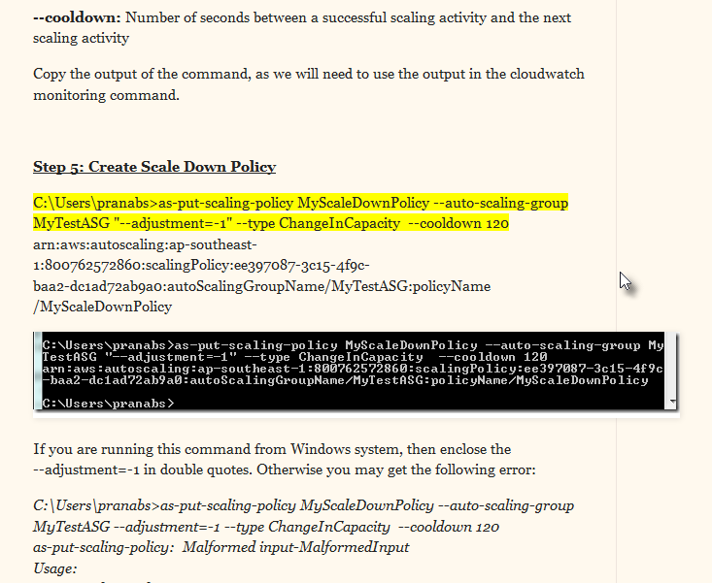
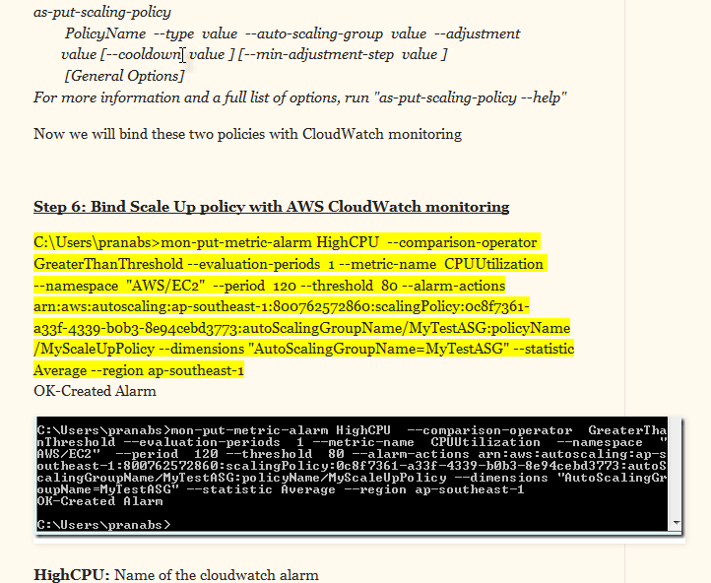
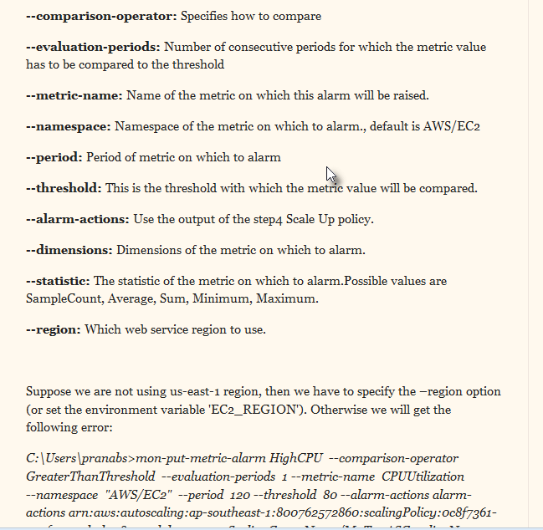
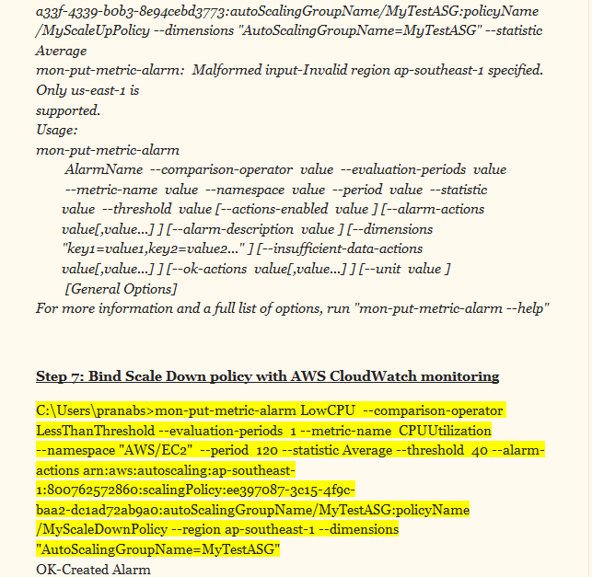
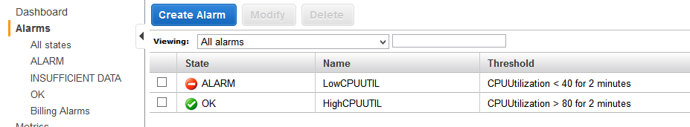
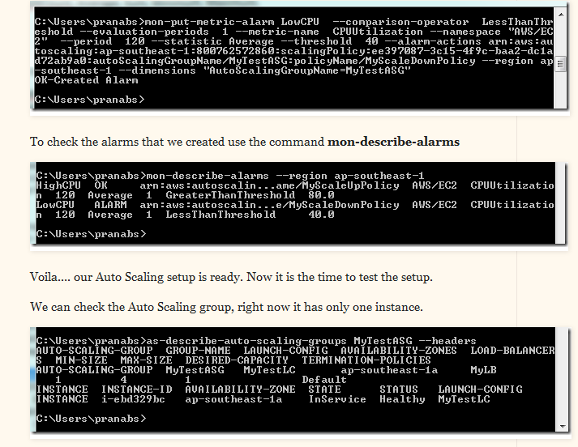

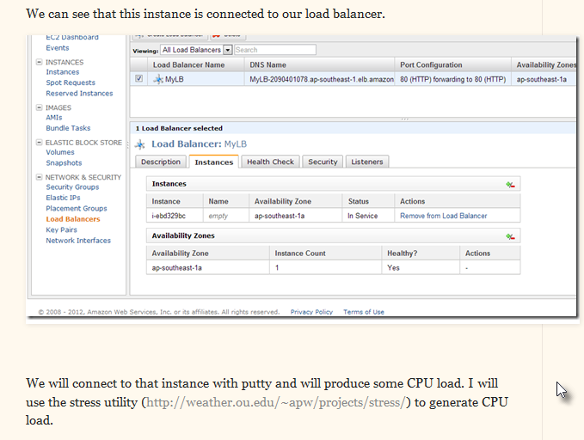
wget http://weather.ou.edu/~apw/projects/stress/stress-1.0.4.tar.gz
tar xzf stress-1.0.4.tar.gz
cd stress-1.0.4
if you are using amazon linux, install c++ compile
yum install gcc
./configure && make && sudo make install

[In debian /ubuntu you can install using apt-get install stress]
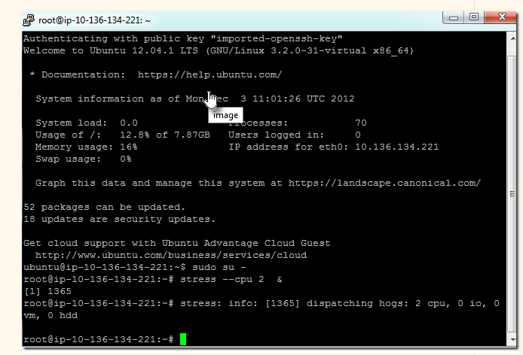
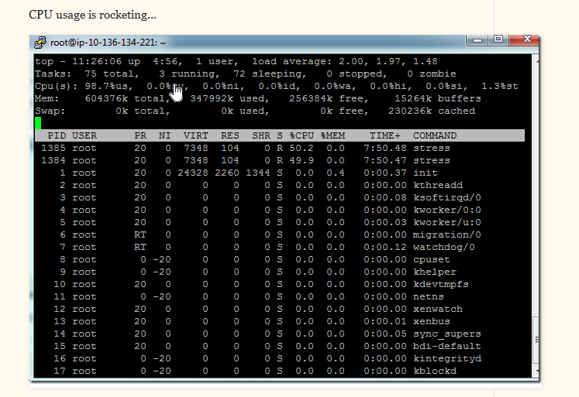
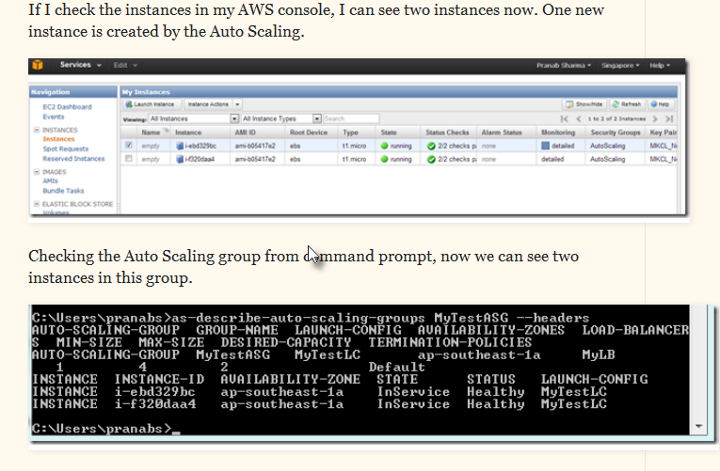
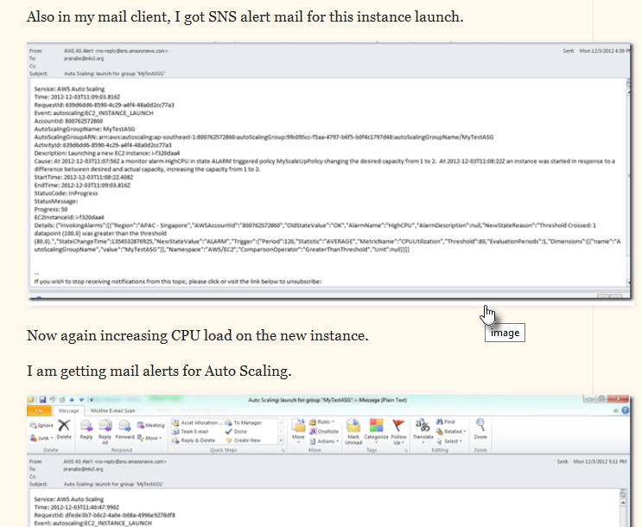
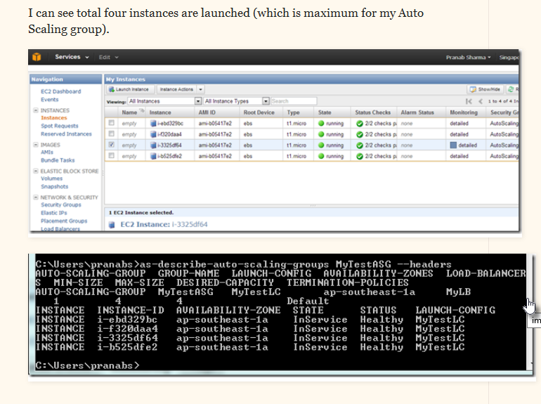
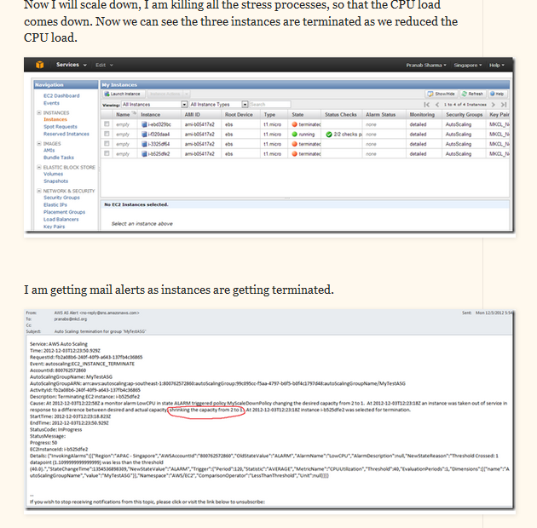
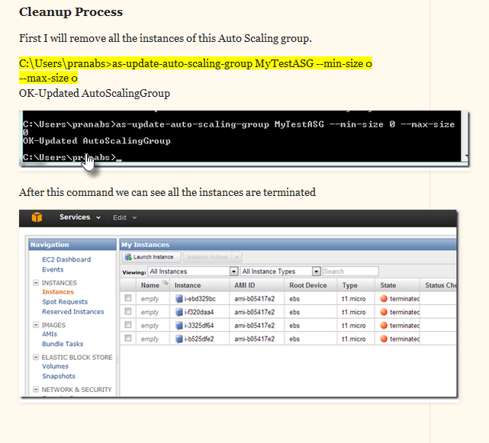
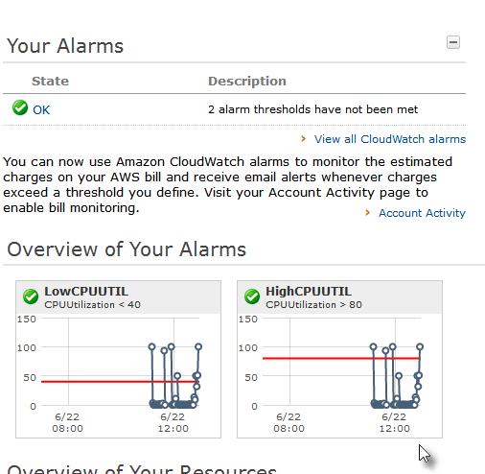
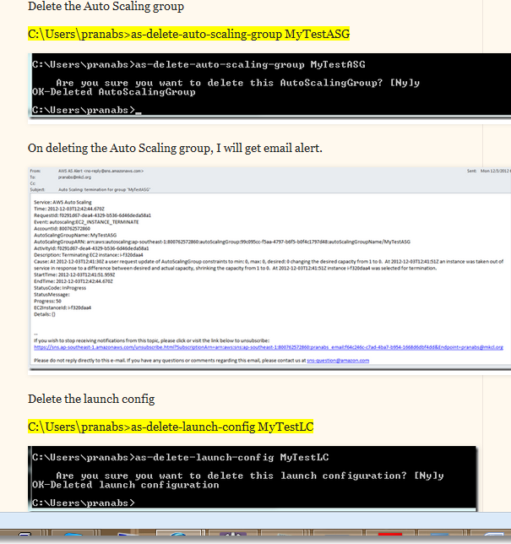
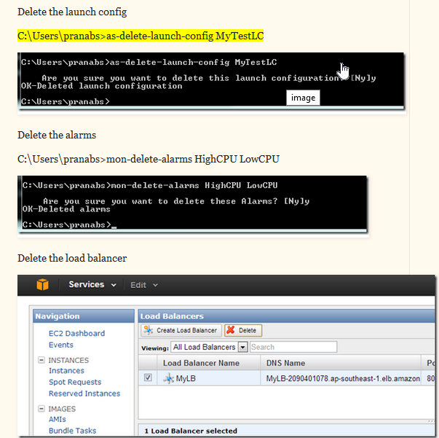
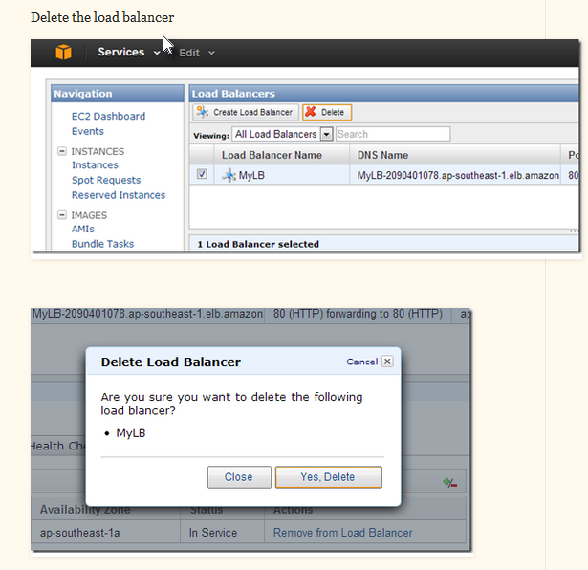

Autoscaling : Advanced concepts

Create a Schedule for Scaling Actions
You can create a schedule for scaling one time only or for scaling on a recurring schedule.
To schedule scaling for one time only
1. Use the as-put-scheduled-update-group-action with the following values:
• Name of your scheduled action = ScaleOut
• Auto Scaling group name = my-test-asg
• Desired Capacity = 3
• Start time = “2014-01-12T08:00:00Z”
Note
If you try to schedule your action in the past, Auto Scaling returns an error message.
Auto Scaling supports the date and time expressed in "YYYY-MM-DDThh:mm:ssZ" format in UTC/GMT only.
2. Your command should look similar to the following example:
as-put-scheduled-update-group-action ScaleUp --auto-scaling-group my-test-asg --start-time "2014-01-12T08:00:00Z" --desired-capacity 3
3. You might want to reduce the number of running instances in your Auto Scaling group to 1 after a certain time. Use as-put-scheduled-update-group-action by specifying a later date for changing the desired capacity to 1.
• Name of your scheduled action = ScaleIn
• Auto Scaling group name = my-test-asg
• Desired Capacity = 1
• Start time = “2014-01-13T08:00:00Z”
Note
If you try to schedule your action in the past, Auto Scaling returns an error message.
Auto Scaling supports the date and time expressed in "YYYY-MM-DDThh:mm:ssZ" format in UTC/GMT only.
Your command should look similar to the following example
as-put-scheduled-update-group-action ScaleDown --auto-scaling-group my-test-asg --start-time "2014-01-13T08:00:00Z" --desired-capacity 1

To create scheduled actions for scaling on a recurring schedule
1. The following example creates a scheduled action to scale on a recurring schedule that is scheduled to execute at 00:30 hours on the first of January, June, and December every year. To create a scheduled action based on recurring schedule, use the as-put-scheduled-update-group-action with the following parameters:
• Name of your scheduled action = Scaleout-schedule-year
• Auto Scaling group name = my-test-asg
• Desired Capacity = 1
• Recurrence = “30 0 1 1,6,12 0”
Note
If you try to schedule your action in the past, Auto Scaling returns an error message.
You must specify the recurrence schedule using the Unix cron syntax format.

Your command should look similar to the following example:
as-put-scheduled-update-group-action scaleup-schedule-year --auto-scaling-group my-test-asg --recurrence “30 0 1 1,6,12 0” --desired-capacity 3
Verify that the Auto Scaling Group is Scheduled for Scaling
To verify that your Auto Scaling group is scheduled for scaling
1. Use the as-describe-scheduled-actions command to list all the scheduled actions attached to your Auto Scaling groups that are still waiting to be executed. Once a scheduled action is completed, it is automatically deleted and, thus, no longer visible in the list of planned actions.
Your command should similar to the following example:
as-describe-scheduled-actions --auto-scaling-group my-test-asg --headers
2. The information you get should be similar to the following example:
UPDATE-GROUP-ACTION my-test-asg ScaleOut 2013-05-12T08:00:00Z 3
UPDATE-GROUP-ACTION my-test-asg ScaleIn 2013-01-13T08:00:00Z 1
3. If the scheduled action is already executed, use as-describe-scaling-activities by specifying the name of your Auto Scaling group and using the --show-xml option.
Your command should look similar to the following example:
as-describe-scaling-activities --auto-scaling-group my-test-asg --show-xml
4. The information you get should be similar to the following example.
<DescribeScalingActivitiesResponse xmlns="http://autoscaling.amazonaws.com/doc/2
011-01-01/">
<DescribeScalingActivitiesResult>
<NextToken>71382dd3-75af-4a57-9c23-988fdcb1866a</NextToken>
<Activities>
<member>
<StatusCode>Successful</StatusCode>
<Progress>100</Progress>
<ActivityId>7d1a9dd2-7b53-4334-8a5f-5fa2a9731d64</ActivityId>
<StartTime>2013-01-30T03:00:51.931Z</StartTime>
<AutoScalingGroupName>my-test-asg</AutoScalingGroupName>
<Cause>At 2013-01-30T03:00:21Z a scheduled action update of AutoScalingGroup constraints to min: 1, max: 5, desired: 3 changing the desired capacity fro
m 1 to 3. At 2013-01-30T03:00:21Z the scheduled action ScaleOut executed. Setting desired capacity from 1 to 3. At 2013-01-30T03:00:51Z an instance was started
in response to a difference between desired and actual capacity, increasing the capacity from 1 to 3.</Cause>
<Details>{}</Details>
<Description>Launching a new EC2 instance: i-aacc62da</Description>
<EndTime>2013-01-30T03:02:01Z</EndTime>
</member>
You can determine whether instances were launched due to a scheduled action by examining the description in the Cause field. Activities launched as a direct result of a scheduled action will have a reference to the specific action name in the Cause field of the corresponding scaling activity. The Cause field in the example shows the scheduled action taken for the Auto Scaling group my-test-asg.
Congratulations! You have successfully created a scaling plan for your Auto Scaling group based either on a specific time or recurring schedule.

e.g
[FOR IST to UTC/GMT conversion click: IST2UTC
H:\000 CLOUD\AWS\AUTO_SCALING\AutoScaling-1.0.61.1\bin> as-put-scheduled-update-group-action Scaleup --auto-scaling-group sgpmar4 --start-time "2014-03-04T19:17:00Z" --max-size 5 --desired-capacity 2
OK-Put Scheduled Update Group Action

H:\000 CLOUD\AWS\AUTO_SCALING\AutoScaling-1.0.61.1\bin>as-put-scheduled-update-group-action Scaledown --auto-scaling-group sgpmar4 --start-time "2014-03-04T19:20:00Z" --max-size 4 --desired-capacity 1
OK-Put Scheduled Update Group Action

H:\000 CLOUD\AWS\AUTO_SCALING\AutoScaling-1.0.61.1\bin>as-describe-auto-scaling-groups sgpmar4
AUTO-SCALING-GROUP sgpmar4 lcmar4 us-east-1a mylb 1 3 1 Default
INSTANCE i-ac6d5082 us-east-1a InService Healthy lcmar4

H:\000 CLOUD\AWS\AUTO_SCALING\AutoScaling-1.0.61.1\bin>as-describe-scheduled-actions
UPDATE-GROUP-ACTION sgpmar4 Scaleup 2014-03-04T19:17:00Z 5 2
UPDATE-GROUP-ACTION sgpmar4 Scaledown 2014-03-04T19:20:00Z 4 1

H:\000 CLOUD\AWS\AUTO_SCALING\AutoScaling-1.0.61.1\bin>as-describe-scheduled-actions
UPDATE-GROUP-ACTION sgpmar4 Scaledown 2014-03-04T19:20:00Z 4 1

H:\000 CLOUD\AWS\AUTO_SCALING\AutoScaling-1.0.61.1\bin>as-describe-auto-scaling-groups sgpmar4
AUTO-SCALING-GROUP sgpmar4 lcmar4 us-east-1a mylb 1 5 2 Default
INSTANCE i-ac6d5082 us-east-1a InService Healthy lcmar4
INSTANCE i-dc605df2 us-east-1a Pending Healthy lcmar4
H:\000 CLOUD\AWS\AUTO_SCALING\AutoScaling-1.0.61.1\bin>as-describe-auto-scaling-groups sgpmar4
AUTO-SCALING-GROUP sgpmar4 lcmar4 us-east-1a mylb 1 5 2 Default
INSTANCE i-ac6d5082 us-east-1a InService Healthy lcmar4
INSTANCE i-dc605df2 us-east-1a InService Healthy lcmar4

H:\000 CLOUD\AWS\AUTO_SCALING\AutoScaling-1.0.61.1\bin>as-describe-scheduled-actions
No Scheduled Actions found

H:\000 CLOUD\AWS\AUTO_SCALING\AutoScaling-1.0.61.1\bin>as-describe-auto-scaling-groups sgpmar4
AUTO-SCALING-GROUP sgpmar4 lcmar4 us-east-1a mylb 1 4 1 Default
INSTANCE i-ac6d5082 us-east-1a Terminating Healthy lcmar4
INSTANCE i-dc605df2 us-east-1a InService Healthy lcmar4

